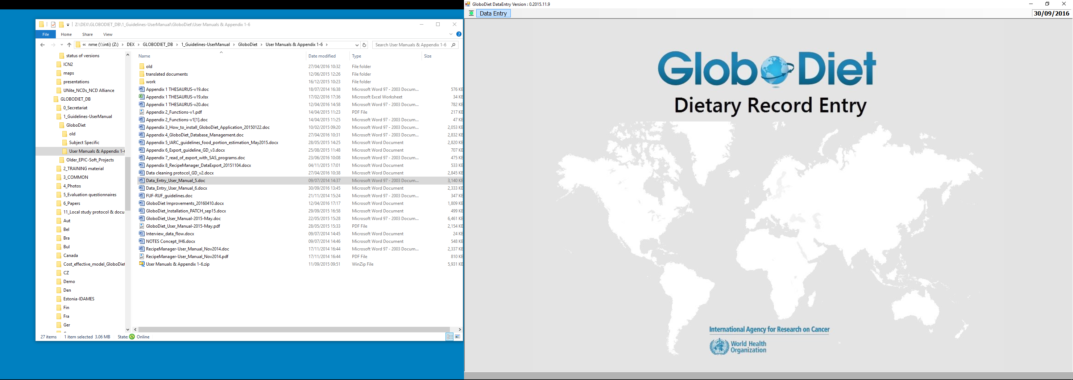

GLOBODIET DATA ENTRY APPLICATION
USER’S MANUAL
Dietary Exposure Assessment Group (DEX)
International Agency for Research on Cancer

GLOBODIET DATA ENTRY APPLICATION
USER’S MANUAL
Dietary Exposure Assessment Group (DEX)
International Agency for Research on Cancer

Lyon, France, April 2016

Any queries on the circulation, reproduction or other use of the material should be directed to:

Dietary Exposure Assessment Group
International Agency for Research on Cancer
150, cours Albert Thomas
69372 Lyon Cedex 08, France
Tel. : +33 (0)472 73 8321
slimani@iarc.fr

This copy of the guidelines is part of the GLOBODIET methodology and is protected as pre-existing know-how (PEKH) during and after the current project. Proper acknowledgement of the use of the GLOBODIET methodology, including the GLOBODIET guidelines, should be made in any document, report or scientific paper resulting from the use of this methodology. Like all IARC products disseminated for educational and research purposes, the entire GLOBODIET methodology enjoys copyright protection in accordance with the provisions of Protocol 2 of the Universal Copyright Convention. All rights are therefore reserved.

We acknowledge the financial support of the European Food Safety Authority (EFSA) under the PANCAKE project (AGREEMENT NUMBER – EFSA/DATEX/2009/02 “Pilot study in the view of a Pan-European dietary survey-infants and children”). The EFSA is not liable for any use of the information contained herein.

1. INTRODUCTION 4
2. THE GLOBODIET DATA ENTRY APPLICATION 5
2.1. General structure of the GLOBODIET DATA ENTRY application 5
2.2. Hardware requirements, installation and launching of GLOBODIET 5
2.3. How to use GLOBODIET 5
2.4. Restore of records 7
3. RECOMMENDATIONS BEFORE STARTING 9
4. PROCEDURES FOR ENTERING A FOOD DIARY 10
4.1. Getting GLOBODIET started 10
4.2. General information on operator, subject and day of record 11
4.3. Food/recipe description and quantification 17
4.3.1. Introduction 17
4.3.2. Food consumption occasion (FCO) 17
4.3.3. Search and identification of food/recipe items 18
4.3.4. Description of food/recipe items 21
4.3.5. Quantification of food/recipe items 27
4.3.6. Menu/functions available on food/recipe description/quantification screens 31
4.4. Quality controls 35
4.5. Vitamins and other supplements 38
4.6. Ending a data entry session of a food diary 40
5. PROCEDURES FOR EDITING A FOOD DIARY 42
6. APPENDICES 44
6.1. Appendix 1: Thesaurus on facets and descriptors 44
6.2. Appendix 2: Summary of GLOBODIET functions 44
6.3. Appendix 3: How to install and uninstall GLOBODIET 44

- INTRODUCTION
The GLOBODIET application (short: GLOBODIET) is a menu-driven software developed to conduct standardized interactive 24-HDR (24-hour dietary recall) interviews or for entering data as collected by means of a food diary using the data entry version of GLOBODIET (GLOBODIET DATA ENTRY application).
GLOBODIET was initially developed for use in a large-scale European multi-centre study, the European Prospective Investigation into Cancer and Nutrition (EPIC). It was developed by the International Agency for Research on Cancer (IARC) in collaboration with all national EPIC centers. The software was adapted for each participating country and translated into local languages to standardize interviews between the 24 EPIC centers (used as a calibration method).
The European Food Consumption Survey Method (EFCOSUM) project published recommendations for the methods to be used in pan-European monitoring surveys including the advice to use GLOBODIET to standardize 24-HDR as the best way forward for future pan-European dietary monitoring.
The European Food Consumption Validation (EFCOVAL) project aimed to develop further and validate the use of repeated 24-HDR using GLOBODIET for the intake assessment of foods, nutrients and potentially hazardous chemicals for surveillance purposes relevant to health and safety policies in Europe. In EFCOVAL, GLOBODIET was updated and further developed on various aspects. One of the major improvements of the updated GLOBODIET is the possibility of a project-specific customization.
Within the PANCAKE project (‘Pilot study in the view of a Pan-European dietary survey-infants and children’), a project funded by the European Food Safety Authority (EFSA), a data entry version of GLOBODIET was developed. This data entry version should facilitate and standardize food consumption data collected by food diaries or similar methods among children (but also in elderly) and ensure the highest possible level of comparability with the data collected in adults using 24-HDR interviews with GLOBODIET.

Although GLOBODIET has been designed in such a way that most of the rules and criteria for conducting the interview or for entering data are already pre-defined and can be easily updated and adapted (e.g. list of foods or recipes, type and number of questions to be systematically asked in order to describe foods, quantification methods to estimate food or recipe portion sizes), the role of the interviewers/operators remains essential to ensure the quality and the standardization of the data collection. It is important that, before using the GLOBODIET DATA ENTRY application, the person entering the data should be well acquainted with GLOBODIET, the related databases (e.g. food/recipe lists, food or recipe classification system) and that the software-specific rules, as indicated in the annex documents or mentioned during the local training course, are strictly followed.

- THE GLOBODIET DATA ENTRY APPLICATION
  - General structure of the GLOBODIET DATA ENTRY application
Data entry using the GLOBODIET DATA ENTRY application is structured into four main steps as described in more detail in chapter 4:
- General information on the operator (short for “data entry operator”), the subject and the recorded day
- Food/recipe description and quantification
- Quality control at the energy and macronutrient level
- Dietary supplement information

  - Hardware requirements, installation and launching of GLOBODIET
Hardware requirements
The minimum hardware requirements to run GLOBODIET are a PC with Intel (or compatible) Pentium III, using Windows XP service pack 2 (or higher) with a minimum of 512 Mo of Ram and 600 MB of available hard disk space. A 15” screen with a resolution of 1024x768 (or higher) will also be necessary. The database system SQL server express 2008 also needs to be installed.

How to install and uninstall GLOBODIET
Guidelines to install and uninstall the GLOBODIET program are described in detail in Appendix 3.

How to launch GLOBODIET
On the PC desktop, the icon of the GLOBODIET DATA ENTRY application (Screen 2.1) is displayed. This icon can be used to launch (‘double click’) the GLOBODIET DATA ENTRY application; the window as shown on Screen 2.2 appears. In case you cannot find the icon on your PC desktop, go to drive ‘C’ of your PC where you should find the folder ‘GloboDiet-DataEntry’; open the folder and double click ‘DataEntry.exe’. If you cannot access this folder, ask your IT admin.

Screen 2.1 Desktop icon of the GLOBODIET DATA ENTRY application

  - How to use GLOBODIET
Before GLOBODIET can be used, some basic operations such as how to execute a function, how to select an option, how to ‘escape’ from a window etc. need to be known. Sometimes, several possibilities for the same action are available (mouse, keyboard, …). These possibilities are briefly explained in this chapter and won’t be repeated in the remainder of the manual.

Moving the cursor
Like in any Windows program, the mouse can be used to move the cursor and to select menu options. In addition, the ‘arrow keys’ and ‘enter’ can be used to navigate through the screen and select from the option lists.
- Use the UP-DOWN or LEFT-RIGHT ARROW-keys to move within a list or from one field to another available on the same screen.
- Use the TAB function to move from one window to another available on the same screen; to move upwards in windows or fields, use SHIFT-TAB.
- Use the mouse to move the cursor to the appropriate place and (double) click the left button for selecting an option.

Screen 2.2 Start screen of the GLOBODIET DATA ENTRY application

Select a menu or activate a function
Most of the menus or functions that can be used on a screen are available in a pull-down menu. The pull-down menu is accessible by clicking the menu headings on the top-left corner of the window (e.g. ‘Record’, ‘Food Items’). Different methods can be used to access the menus and execute their corresponding functions:
- HOTKEYS: Some functions are accessible by means of a HOTKEY; press Alt and the first letter of the menu on top of the screen to activate this menu with a subsequent selection of a specific function (e.g. Ctrl+F5 to add a food consumption occasion during the quantification/description step); HOTKEY functions are indicated in the menu and a comprehensive list of HOTKEYS is given in Appendix 2.
- KEY functions: Some functions are also accessible with a KEY-function (e.g. F4 for opening the food/recipe list to search/add an item to a given food consumption occasion); press the corresponding key at the top of your keyboard (a list of key functions can be found in Appendix 2).
- KEYBOARD: Position the cursor on the field of the menu or function by means of the ARROW-keys or the mouse and press RETURN (‘enter’) to confirm the selection.
- MOUSE: Position the cursor on the field of the function with the mouse and click the left button to select it: click once to select a function, double click to select an option from a list or to open a window; right click to see the options/menu, the proposed list is the merge of the different menu functions, then left click to select the function.
The functions available at the bottom of the screen are accessible with both their KEY functions and with the mouse (place the cursor on the indicated function-key and double click):
- F1 (NOTES): to enter notes at any time during the data entry session; notes attached to an item are flagged by an additional square in front of the green square (if food), or the blue square (if recipe)
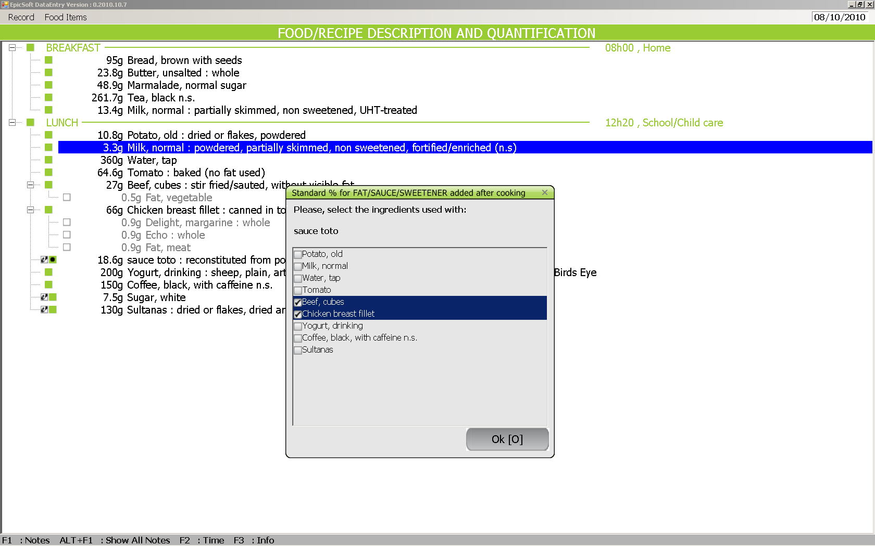

- ALT FI (SHOW ALL NOTES): to view all notes at any time during the data entry session
- F2 (TIME): gives the duration since data entry has been launched, i.e. when NEW RECORD is chosen (not in EDIT RECORD mode)
- F3 (INFORMATION): to EDIT or MODIFY subject’s data, recorded day and wake-up time at any time during the data entry

Select an option from a list
An option from a list (e.g. food list) can be selected by:
- KEYBOARD: position the cursor on the option using the ARROW-keys and press RETURN to confirm the selection.
- MOUSE: position the cursor on an option and double click to select it.

If more than one option can be selected from a list (e.g. in the “source”, “flavoured/added component” or “enriched/fortified” facets), tick boxes are proposed on the screen. The selection/un-selection can be made by:
- KEYBOARD: with the space bar.
- MOUSE: double click with the mouse .
A ticked box at the front of each descriptor confirms the selection, the selected descriptors are listed on the right side of the window; to exit click ‘OK’.

Close or escape from a window or a screen
Confirm the information by selecting the OK function.
Escape from the current window by using the ESC-key or by selecting the "close window" (box with cross) available at the top right corner of the active window.

  - Restore of records
In GLOBODIET, a regular backup is automatically done to prevent information already entered from being lost if a data entry session is interrupted. When the software is reconnected, e.g. after a system crash, a warning message indicates that a pending record has been detected. The record can then be resumed at the place where it was before the interruption by selecting the option RESUME RECORD available in the DATA ENTRY menu.

- RECOMMENDATIONS BEFORE STARTING
Before starting data entry of a food diary, the operators should be trained and well acquainted with the software. Ideally, all operators should have had a training on the software.
Depending on the study/project and the respective administration mode of the food diaries, different ‘parameter features’ of GLOBODIET, which are flexible and need to be selected by the study/project coordinator, are available. Make sure that the correct parameters are pre-selected in the set-up (done by the coordinator).

- PROCEDURES FOR ENTERING A FOOD DIARY
  - Getting GLOBODIET started
Double click the DATA ENTRY icon on the PC desktop.
Confirm the CURRENT DATE or change it if necessary.
Screen 4.1 shows the menu available if clicking the green symbol (upper left corner).
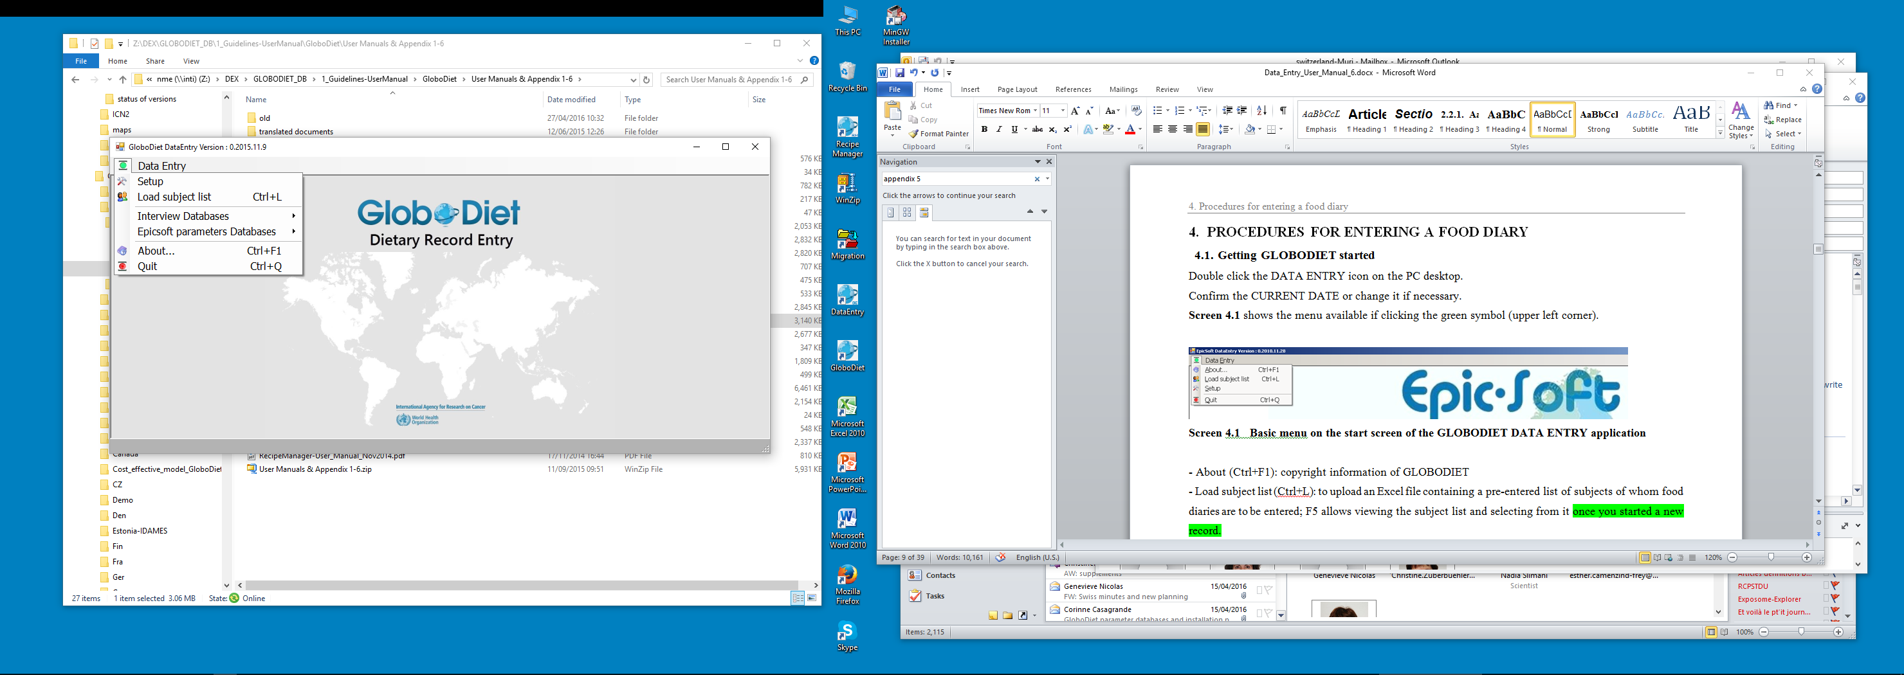
Screen 4.1 Basic menu on the start screen of the GLOBODIET DATA ENTRY application

- About (Ctrl+F1): copyright information of GLOBODIET
- Load subject list (Ctrl+L): to upload an Excel file containing a pre-entered list of subjects of whom food diaries are to be entered; F5 allows viewing the subject list and selecting from it once you started a new record.
- Interview databases See Appendix 4 for the database management
- GloboDiet parameters databases
- Setup (Screen 4.2): British units can be activated by ticking the respective box; whether the current date is prompted at beginning can be activated/deactivated.

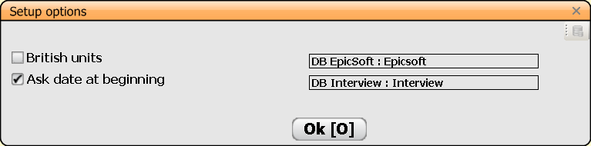
Screen 4.2 Setup options of the GLOBODIET DATA ENTRY application

Selecting the menu ‘Data Entry’:
- NEW RECORD: to start a new record
- EDIT RECORD: to edit a RECORD already entered
- RESUME RECORD: to resume a RECORD interrupted in the unlikely event of a computer system crash

As a memory aid, selected hot key functions are displayed at the bottom of the screen. They may also be activated by double clicking them.
- F1: to enter a note; ‘General notes’ are not linked to a specific food/recipe/dietary supplement, unlike ‘Specific notes’; ‘View all notes’ is also proposed
- Ctrl+F1: available in the description/quantification step, enables viewing all notes
- F2: to view the elapsed time since the beginning of the data entry session in NEW RECORD mode (not in EDIT RECORD mode)
- F3: to view and/or modify the entered data during data entry; select ‘Modify’ or ‘OK’, the latter enables to leave the RECORD data screen and go on the previous task
- F5: only available at the very beginning of the data entry, allows viewing the RECORD list and selecting from it

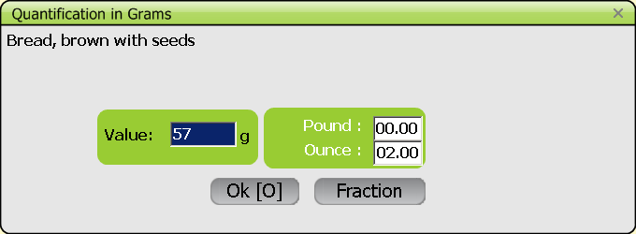
Screen 4.3 Example of a display if British units are activated in the ‘set-up’ screen

  - General information on operator, subject and day of record
Introduction
The general information collected at this step, on the OPERATOR, SUBJECT and the DAY OF RECORD will be used both to keep track of the person who performed the data entry and on the subject whose data was collected and entered. Furthermore, this information will be used to make quality controls during and after the data entry. For example, the data on age, sex, height and weight are used to calculate the energy requirements of the subject, which are compared, at the end of the data entry, with the energy intake as estimated from the food diary (see chapter 4.4. on quality controls). The general information on the ‘ recorded day’ will be used to identify whether or not the subject was on a special diet (e.g. the subject follows a diet or medical treatment) or whether the day recorded was a special day because of religious celebration, travel or other.
Note that the operator can always use the mouse similarly like it is being used in other Windows programs. However, because of practical reasons, this Windows functions are not elaborated in this manual and only the keyboard functions are briefly described below.

Description of GLOBODIET DATA ENTRY application screens and fields
Screen 4.4 shows the start screen to either confirm the current date or to change it if necessary.
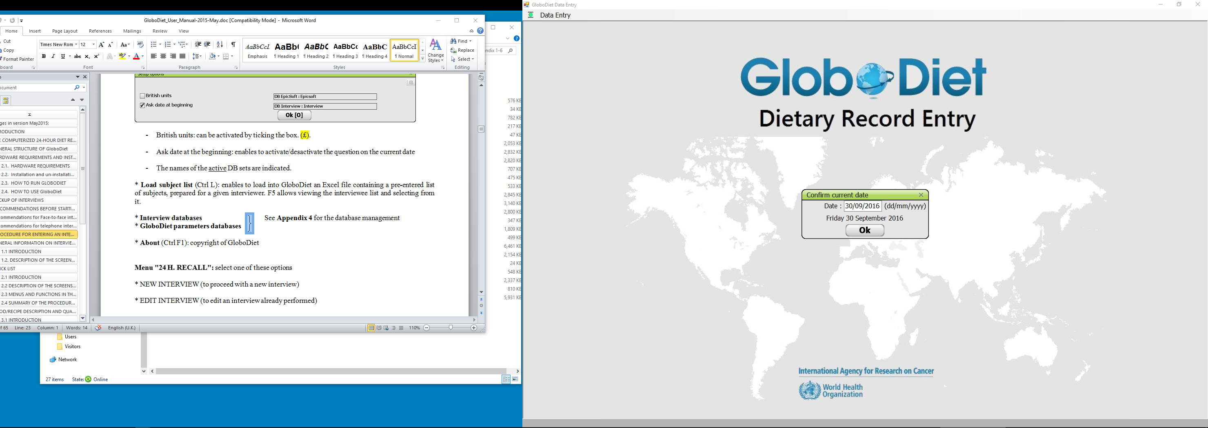
Screen 4.4 GLOBODIET DATA ENTRY application start screen with date confirmation

CENTER (COUNTRY) LIST screen
Select the center from the ‘Center (Country) List’ (automatically displayed), where the study was conducted, by moving the blue bar with the arrow-keys to the center to be selected and press ‘enter’ (Screen 4.5).
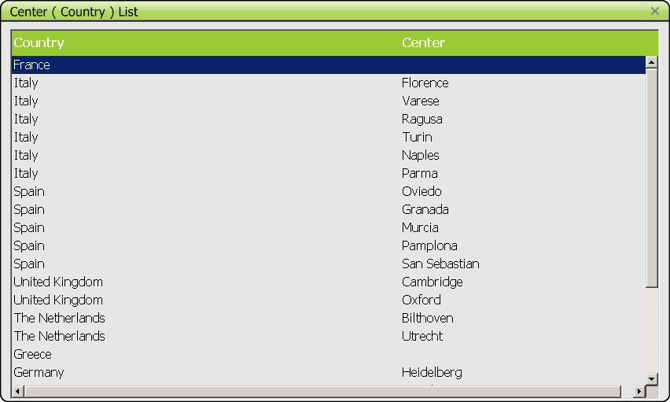
Screen 4.5 Example of list of available centers involved in a project

OPERATORS screen
Confirm the name of the OPERATOR. If it is not the correct one, press NO and select the correct centre and name of the OPERATOR from the pre-defined list (Screen 4.6).

SUBJECT screen
Fill in each of the fields appearing on this screen (e.g. NAME, SURNAME) (Screen 4.7):
* Manually: enter manually the information in each field and confirm by pressing RETURN/tab
* Automatically: all information about the SUBJECT can be stored in a pre-defined file and can be accessed by pressing the F5 key; select the subject from the LIST OF THE SUBJECTS screen, then the information regarding this subject is automatically displayed in the respective fields

- The subject identification code may contain numbers as well as characters; the code is decomposed as follows: 3 first characters define the country code (automatically assigned); the 3 subsequent characters define the center code (automatically assigned); 24 other characters are available to be freely specified as needed.
- For the variable SEX: Select the MALE or FEMALE option
- Confirm with the ‘OK’ button to exit the screen

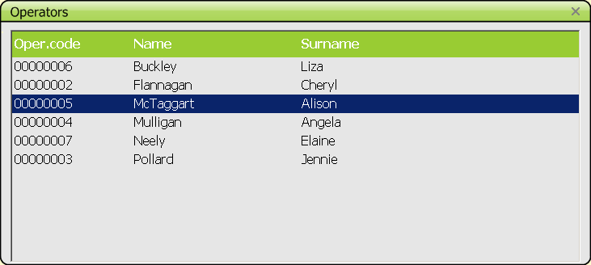
Screen 4.6 Example of a pre-defined list of operators

When ending data entry of day 1, in the “save window” a question is prompted: ”Do you want to add another record for the same subject ? Yes/No” (to facilitate data entry of consecutive days). If “Yes” is selected, data is saved and general information on subject is kept in memory and automatically displayed on “subject data screen” (same for “special diet”). Information already entered for a subject is displayed, but can be modified if necessary.

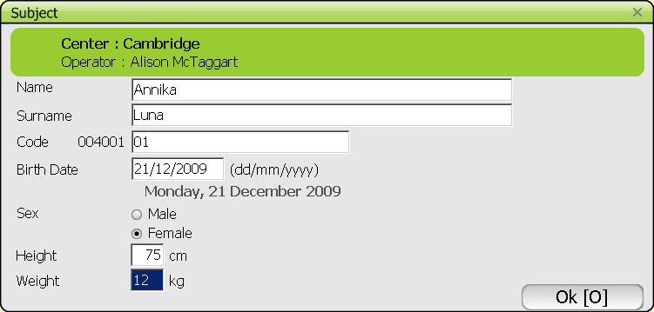
Screen 4.7 Example of filled in SUBJECT screen

RECALLED DAY AND WAKE UP TIME screen
a. RECALLED DAY
The day when the food diary was filled in can be selected from a calendar by clicking on the respective day (Screen 4.8) or by typing in the date directly. NB: It is not possible to enter a date that is in the future.

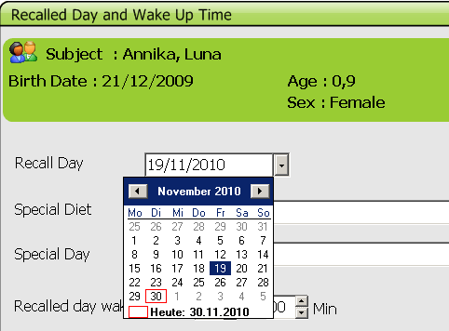
Screen 4.8 Example for selecting the date of the food diary using the ‘calendar function’

b. SPECIAL DIET and SPECIAL DAY
To select one (or several) Special diet or day, the user needs to press the ENTER button (or double click the left mouse button) to access the predefined list. To select the options the user can use the mouse (like in other Windows applications) or can use the arrows in combination with the space bar.
When selecting the option ‘other’, the user will have the possibility to enter another special day/diet in the designated field ‘Other’ (Screen 4.9).

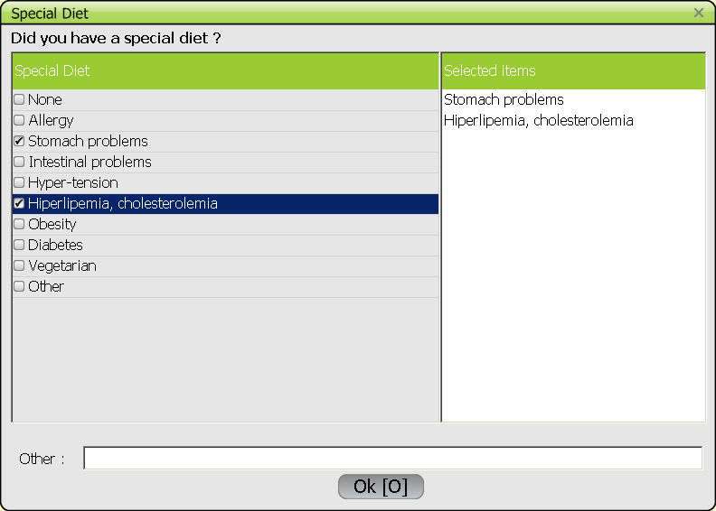
Screen 4.9 Example of a SECIAL DIET screen with selected items

c. WAKE UP TIME and NEXT DAY WAKE UP TIME
Manually report the hour and minutes of the wake-up times in the two corresponding fields and confirm with ‘OK’ to exit the screen/window. The wake-up times need to be expressed in the interval 0-24 hours, the use of a.m./p.m. is not possible (Screen 4.10).
When completed, GLOBODIET automatically proceeds to the next step. To view and/or modify the subject’s data during the data entry, press F3 and select ‘Modify’ or ‘OK’; the latter enables to leave the subject’s data screen and continue accordingly.

NB: A number of features of the GLOBODIET DATA ENTRY application are ‘parametrable’ and will depend on the project coordinator’s decisions and respective ‘parameter settings’.

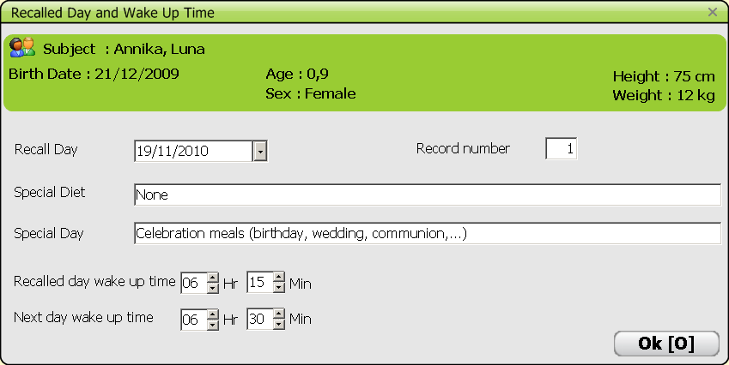
Screen 4.10 Example of filled in RECALLED DAY AND WAKE UP TIME screen

A record number can be entered manually by the operator (note: “recode” can be performed afterwards using the Interview Manager application) (Screen 4.10).

  - Food/recipe description and quantification
    - Introduction
At the FOOD/RECIPE DESCRIPTION & QUANTIFICATION step, each of the items reported in the food diary is identified, described and quantified according to pre-defined rules. After the ‘General information’ step, the screen as shown below is displayed (Screen 4.11).
Four sub-steps can be distinguished:
- selection of food consumption occasion (FCO),
- search/identification,
- description,
- quantification.
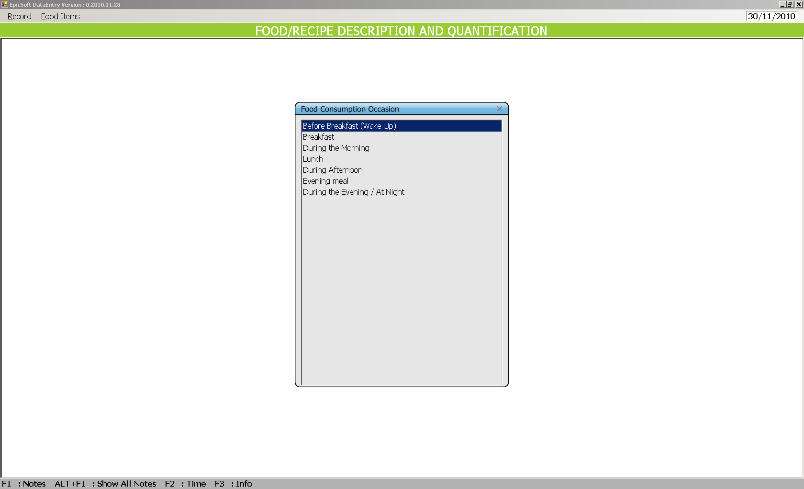
Screen 4.11 Select a pre-defined FOOD CONSUMPTION OCASSION

    - Food consumption occasion (FCO)
First, a FCO has to be selected from a pre-defined list by moving the blue bar with the ‘arrow keys’ up or down followed by ‘enter’ (Screen 4.11).
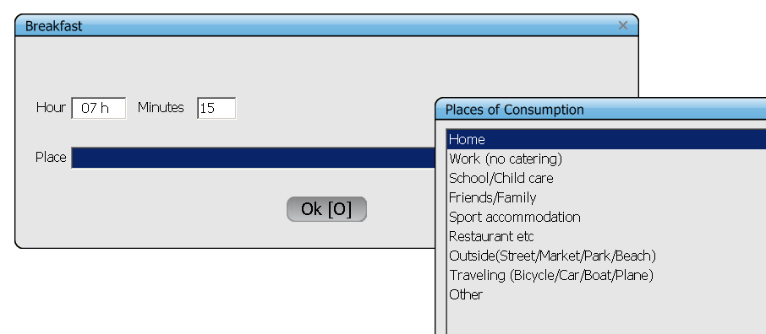
Screen 4.12 Enter TIME & PLACE of the FOOD CONSUMPTION OCCASION

Then, time & place are entered and selected from a pre-defined list respectively (Screen 4.12). Note that the list of places of consumption may vary depending on the project/study (pre-defined in the project’s common files). To select a place of consumption, double click with the right mouse button or press ‘enter’ in the designated blue field. Then move the blue bar up or down using the ‘arrow keys’, press ‘enter’ and confirm with ‘OK’ to arrive at the next sub-step (Screen 4.13).
Screen 4.13 Example screen after defining the first FOOD CONSUMPTION OCCASION
    - Search and identification of food/recipe items
Description of the ‘SEARCH FOR’ screen
To add an item as recorded in the food diary under the respective FCO, either press ‘enter’ on the FCO (where the blue bar is located) or go to the ‘Food Items’ menu and click ‘Add item’ (Screen 4.14) or simply press ‘F4’ on the keyboard.
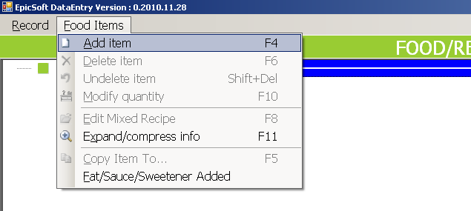
Screen 4.14 Adding an item to a FOOD CONSUMPTION OCCASION

Then, the food and recipe lists are displayed (Screen 4.15). The food and recipe lists, classified by default in alphabetical order, are displayed in the same SEARCH FOR screen but in separated parts of the window.
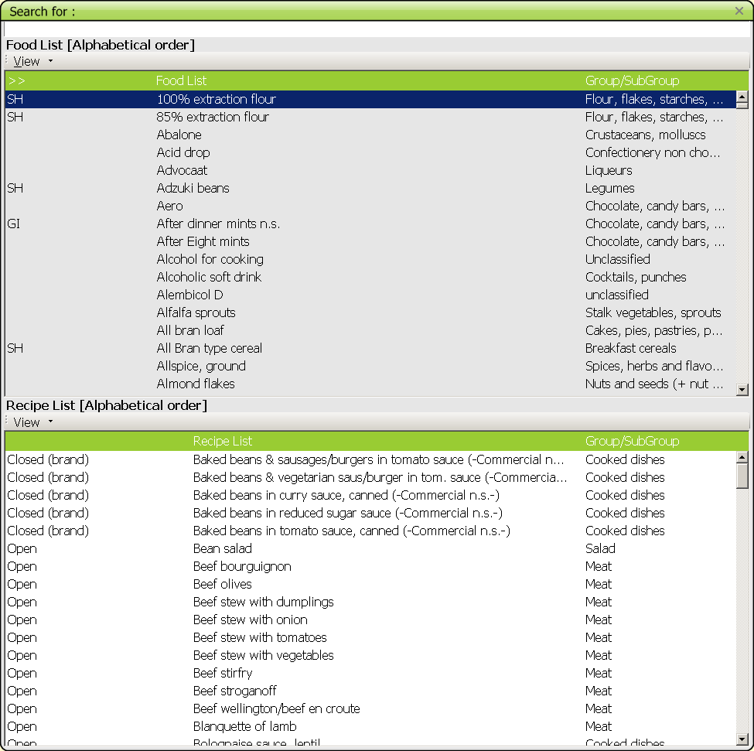
Screen 4.15 FOOD and RECIPE list by default in alphabetical order
Three alternatives to perform a search are possible: a) typing in the name of the item using the default alphabetical order (Screen 4.16), b) using the GROUP/SUB-GROUP function to display the available items of the respective GROUP/SUB-GROUP (Screen 4.17), or c) by SEARCH on a specific string, for example ‘-pudding-‘ (Screen 4.18).

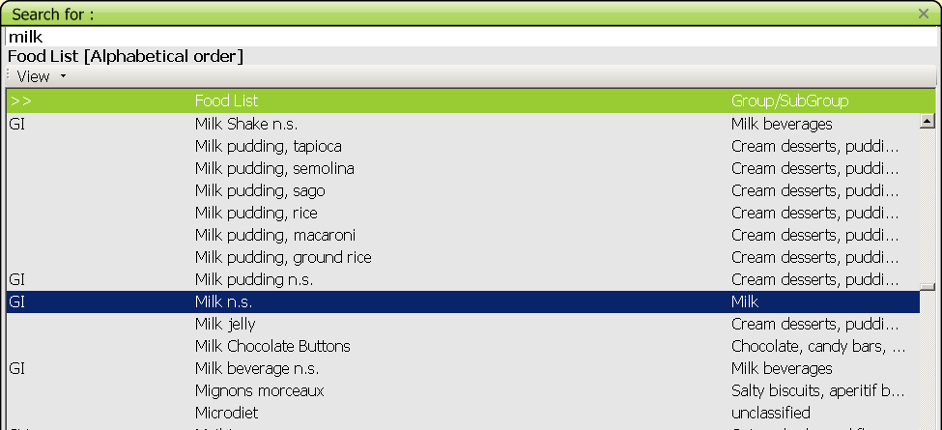
Screen 4.16 Example for a search using item name and alphabetical order of the food list

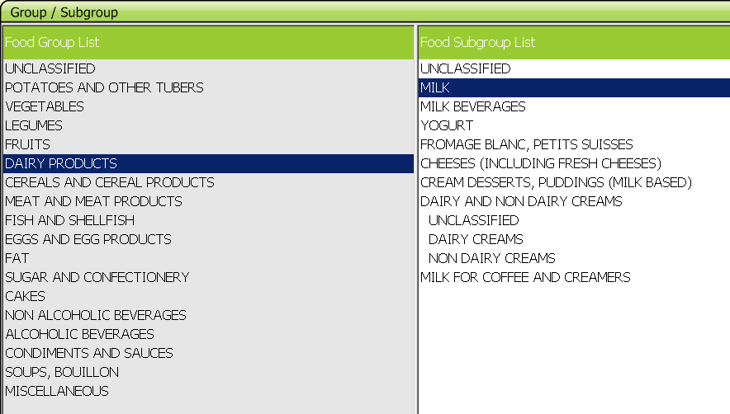
Screen 4.17 Example for a search using GROUP/SUB-GROUP

Menus and functions available in the SEARCH FOR screen
VIEW menu: This menu is the same for foods and recipes, except for the function ‘GI AT THE BOTTOM’ (Generic Items at the bottom) that is only available for the food list (Screen 4.19).
* GROUP/SUB-GROUP (F4): To display the list by group/sub-group of the classification. If this option is selected, the GROUP and SUB-GROUP lists are proposed and shown in different windows on the same screen. When selecting (only) a group, all the foods/recipes in this group are displayed, if a sub-group is selected only the foods/recipes classified in that sub-group are displayed.
* ALPHABETICAL (F5): This option displays the food (or recipe) lists classified in alphabetical order (default).
* GI AT THE BOTTOM: When the SEARCH by food GROUPS/SUB-GROUPS is selected, this option enables to have the generic items (GI) reported at the bottom of the displayed list. Select again to de-activate (function only available for the food list).
* SEARCH (Ctrl+F): This function allows a search in the entire food (or recipe) list for all the foods (recipes) containing a given search string, whatever its position in the name (e.g. all the food names containing the term "pudding"). The search is done from the top of the food (or recipe) list classified in alphabetical order. The foods (or recipes) in which the search string has been found are displayed in a separate window.
* NEW FOOD/NEW RECIPE (Ctrl+N): This function can be used during the data entry to add NEW foods (or NEW recipes) reported by the subject but not available in the food or recipe lists. Classify the new item in its group/subgroup, and the facets and quantification methods defined for that group will automatically be shown. If the facet proposed by default is not relevant for describing the new food entered, the option “undefined”, available systematically for each facet, should be selected.

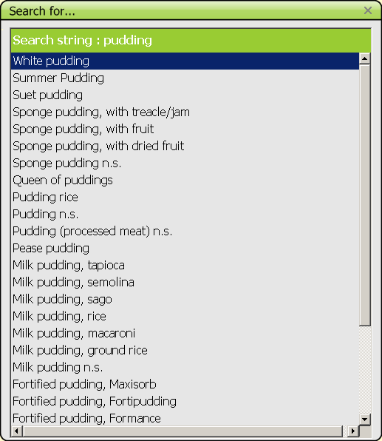
Screen 4.18 Example for a search using ‘search string’

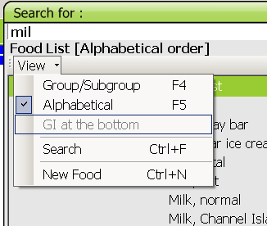
Screen 4.19 The VIEW MENU in the food and recipe list to perform a search

After quantification, the NOTES SCREEN opens automatically in order to enter any additional information that the subject may give about the food/recipe. All new foods entered during the data entry will be flagged (Screen 4.20), for checking, after the data entry, whether the new food needs to be added to the food/recipe files or not.

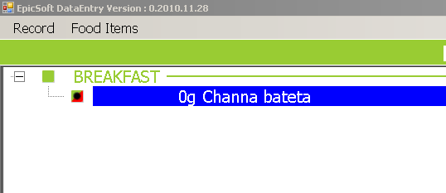
Screen 4.20 Example of a new item added that was not available in the food/recipe lists

    - Description of food/recipe items
All foods and recipes attached to a given FOOD CONSUMPTION OCCASION are described according to a pre-defined and standardized level of detail. The food/ingredient and recipe description consists of a sequence of windows with so-called "facets", representing different characteristics of the food (e.g. cooking method, preservation method, …). The series of facets correspond to the level of detail to describe food/recipe items. Each of these facets is linked to a series of "descriptors" corresponding to the potential answers that the subject should have reported (e.g. "grilled", "roasted", ... for the facet "cooking method").

Description with FACETS
a. Description of the FACET window
Most of the FACET windows have the same structure (Screen 4.21). The name of the facet is indicated at the top of the window with the list of possible descriptors under it. Descriptor options "undefined" and “not registered in the diary” are systematically available if the answer is not known/recorded. In some facets, the cursor is focused, by default, on a descriptor which corresponds to the most frequently given answer to this question (e.g. for the facet "PHYSICAL STATE/FORM AS QUANTIFIED" used to describe milk, the cursor is focused on ‘liquid’). For most of the facets, only one descriptor can be selected.

b. Particular cases
For the facet BRAND NAME/PRODUCT NAME, a pre-defined list of brand names (product names) may be available. However, a new brand name (product name) can be entered by selecting the descriptor "NEW" and entering the brand name manually in the blank field NAME. There is the possibility of an alphabetical search on existing product and brand names.
For some facets such as FLAVOURED/ADDED COMPONENT, FORTIFIED/ENRICHED and SOURCE, TYPE OF MILK/LIQUID USED, TYPE OF FAT USED, the operator can select more than one descriptor.
For the facet TYPE OF FAT USED, the descriptors proposed on the screen correspond to foods from the food list . An option “no fat used” is available at the top of the window. If the subject did not report the type of fat used, a generic item (e.g “fat n.s.”, “vegetable oil n.s.”) should be selected from the food list.
Similarly, for the facet "TYPE OF MILK/LIQUID USED", the descriptors proposed on the screen correspond to liquid foods. Options “no milk/liquid used” and ‘milk/liquid used n.s.’ are available at the top of the window. Note that DAIRY CREAMS could be selected in both facets and should not be counted twice.

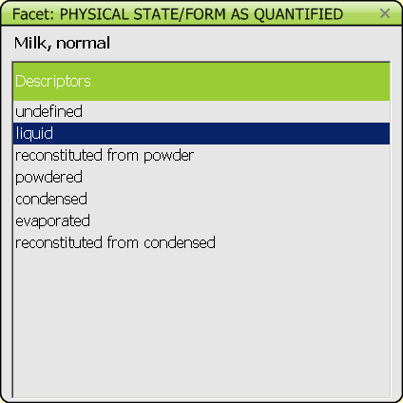
Screen 4.21 Example of a FACET screen

General information of recipes
As mentioned before, different types of recipes can be distinguished within GLOBODIET. Below more details about the procedures available for mixed recipes are given.

Mixed recipe classification
Mixed recipes are classified in a specific classification which is decided at the project level.
As for foods the description and quantification of recipes will depend on their classification.

Ingredients
Ingredients may be chosen from the food and the recipe lists. ‘Sub-recipes’ are recipes used as recipe ingredients.
Note: The latter option is blocked in the current release of GLOBODIET: only foods can be selected as recipe ingredients.
- Substitutable ingredient, marked ‘SUBST’: the ingredients that can be replaced or re-described during the data entry are indicated as substitutable:
- ingredients that are likely to be replaced within the same group/subgroup so that the recipe becomes more flexible
- generic ingredients
- all sauces, fats and dairy creams
- all ingredients with at least one descriptor ‘undefined’ (descriptor 00)
- ingredients with facets 12 Brand name, 13 Skin consumed, 14 Visible fat consumed, or 16 Type of fat used as their descriptors are changed frequently.

Note that the quantity of substitutable ingredients cannot be changed.
The substitution is limited either to the group level whatever the subgroup, sub-group level or sub-sub-group level. No substitution is allowed for some groups/subgroups. Substitution rules are decided for each study by the coordinator.

- Fixed ingredient, marked ‘FIXED’: the ingredients that should not be replaced or re-described during the data entry are fixed:
- if there is no replacement existing such as for spices
- if the ingredient to be substituted has low nutritional impact e.g. stock cubes
- if the ingredient is not likely to vary such as egg
- often, if ingredient appears in the name of the recipe
- all ingredients in strictly commercial recipes

Special rule due to ingredient description:
Some ingredients are automatically set to ‘fixed’ by the recipe manager program if their description has a direct link with quantification. Indeed, the descriptors ‘powdered’, ‘condensed/evaporated’, ‘dried or flakes’ and ‘semi-dried’ cannot be substituted in order to avoid quantification problems. For example, as the quantity is fixed, 5 gram of powdered milk cannot be changed, as nutritionally, it does not correspond to 5 gram of liquid milk. The inverse is also true: liquid milk cannot be re-described as powdered milk.

Mixed recipe pathways
The mixed recipe is first described using the facet Recipe production. Two alternatives occur:
- HOMEMADE: The recipe was prepared at ‘home’ or at ‘friends or relatives’. For those, no brand name will be asked for.
- NOT HOMEMADE: The recipe was not prepared at home but was either produced industrially or by an artisan or prepared in a restaurant (including fast food, canteen, cafeteria…). Thereafter the brand name of the recipe or the name of the restaurant will be captured.

Mixed recipes are separated into 4 major groups (overview on page 26):

I Open recipes
This is a type of mixed recipe where it is assumed that the ingredients reported within the study population can vary considerably. A maximum of flexibility is required.
They may be with or without brand. If with brand, the commercial source (supermarket, restaurant…) as well as the brand name of the recipe will be asked. Within open recipes, three types of recipes exist:
1/ INDIVIDUAL RECIPE: the recipe is homemade and the subject knows the recipe (ingredients AND quantities). The participant indicates all the ingredients with their description and quantification (in the Recipe Ingredient manager window/pop-up). The pre-entered recipe ingredients are displayed as a guide without any ingredient description nor quantification; any ingredient can be added, deleted or substituted. As a visual help, the standard recipe can be displayed with the % as estimated and as consumed.

2/ ADAPTABLE RECIPES:
2a/ The recipe was prepared at home and the subject does not know the recipe. After the description and quantification of the recipe, the standard recipe is proposed (in the Recipe Ingredient manager window/pop-up), the ingredient quantities are based on the consumed portion of the recipe and it is in principle possible to add, delete or substitute any ingredient. Depending on the amounts added and/or deleted in the Recipe Ingredient manager window (definition of a cut-off percentage at the project level), the changes will be marked/taken into account or not on the description/quantification screen and the addition and/or deletion of ingredients will have to be checked/validated after the data entry or not (in EDIT record mode).
2b/ The recipe is commercial. The subject is not asked if the recipe is known. The recipe brand name is to be indicated. After the description and quantification of the recipe, the standard recipe is proposed (in the Recipe Ingredient manager window/pop-up), the ingredient quantities are based on the consumed portion of the recipe and it is in principle possible to add, delete or substitute any ingredient. Depending on the amounts added and/or deleted in the Recipe Ingredient manager window (definition of a cut-off percentage at the project level), the changes will be marked/taken into account or not on the description/quantification screen and the addition and/or deletion of ingredients will have to be checked/validated after the data entry or not (in EDIT record mode).
In both cases, the original standard recipe can be displayed (with the % as estimated and as consumed) as a visual help. The NOTE file is prompted automatically when saving the recipe in case of added and/or deleted ingredient; comments may be added to the automatic notes.

II Closed recipes
This is a type of mixed recipe where it is assumed that the ingredients reported within the study population do not vary, especially in their relative quantity. Therefore, the subject is not asked if he/she can identify, describe and quantify all the ingredients before preparation; only substitutions are allowed.
They may be with or without brand. If without brand, the recipe may be homemade or commercial. In the latter case, the brand name of the recipe will be asked. If with brand, the commercial source (supermarket, restaurant…) as well as the brand name of the recipe will be asked.
The pre-entered recipe is treated as a standard (in the Recipe Ingredient manager window/pop-up) where the ingredients appear with their description and quantification (as the consumed portion of the recipe). The subject is asked if the substitutable ingredients should be replaced or re-described.

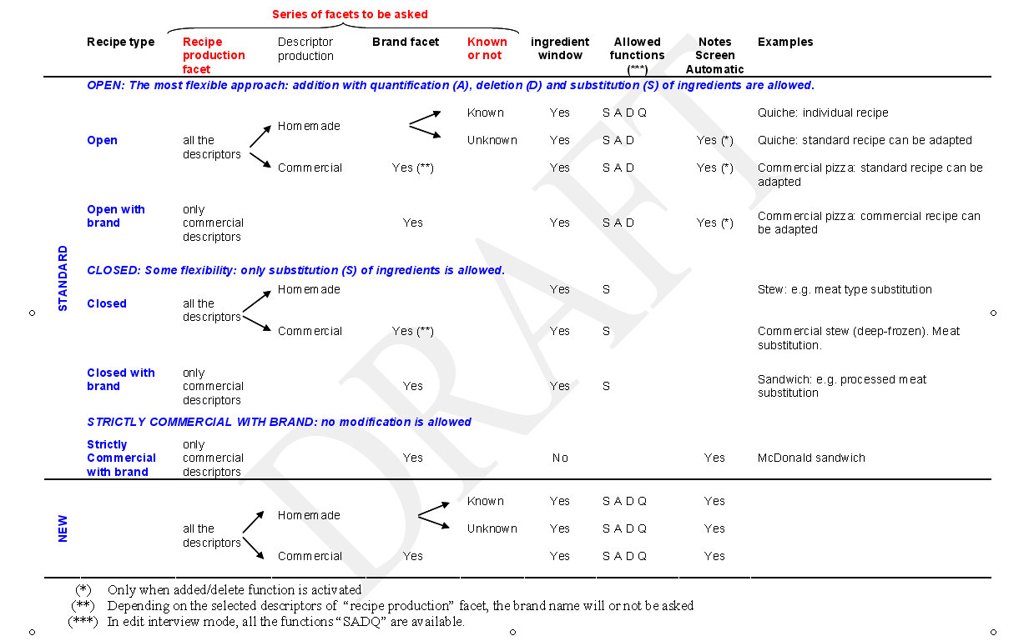

However, quantities cannot be changed, and no ingredient can be deleted or added (this can only be mentioned in the NOTE file). Fixed ingredients can neither be re-described, substituted, nor re-quantified. No ingredient can be added or deleted to the standard recipe: this can only be described in the NOTE file by pressing F1.

III Strictly commercial recipes
They are always with brand: the commercial source (supermarket, restaurant…) as well as the brand name of the recipe will be asked. No ingredient check is performed during the data entry as all ingredients are fixed. The NOTE file is prompted automatically.

IV New recipes
These are recipes that are not available in the recipe list. It will be possible to record them during the data entry.
If the subject knows the recipe, all the ingredients will be described and quantified in the Recipe Ingredient manager window/pop-up. In case the recipe is unknown, the Recipe Ingredient manager window/pop-up will also be proposed to enter a maximum of information. In any case, the NOTE screen is proposed to enter extra information. The validation of the new recipes will be done outside the data entry (in EDIT record mode).

    - Quantification of food/recipe items
Depending on the type of the item, two different procedures are followed to quantify a “simple food” or a “mixed recipe”.

Quantification of a simple food
Simple foods are always quantified "as consumed" with one of their pre-defined quantification methods.

Quantification of a mixed recipe
Recipes are mixed dishes for which the separate ingredients cannot be quantified by the subject in the portion eaten. Note that a bread slice with cheese or a cup of coffee with sugar are two examples for so called ‘composed’ recipes that are described and quantified as separate ‘simple’ foods and the ‘mixed’ recipe pathway should not be used.
A mixed recipe and its ingredients are quantified in three main steps:
1. Quantification of the mixed recipe portion actually consumed by the subject: The estimated quantity refers to the "as consumed" weight of the portion (i.e. the weight of the prepared portion actually consumed by the subject). The methods of quantification are pre-defined for each standard recipe. In the case of a new recipe entered during the data entry, the quantification methods that appear by default defined for the group into which the new recipe has been classified.
2. Quantification of each ingredient of the mixed recipe: For ‘open recipes’, if the subject knows the recipe, the ingredients are quantified as they were before preparation (mainly raw with inedible part), with one of the pre-defined quantification methods for the food (an ingredient is treated as a simple food). If the subject does not know the quantities of each recipe ingredients, the standard quantities of ingredients are taken. Added ingredients will be quantified.
For ‘closed recipes’ and ‘strictly commercial recipes’, the subject is not asked whether he/she knows the recipe and standard quantities of ingredients are taken.
3. Automatic calculation of the weight of each ingredient of the recipe portion actually reported by the subject.

Quantification methods available (and related screens)
Different methods are available for food and recipe quantification. At the time of quantification, the specific methods that can be used are presented in the QUANTIFICATION METHODS screen.
Note that except for the weight and volume methods, the option “other fraction” can be chosen to specify fractions not available in the pre-defined list.

WEIGHT and VOLUME method
These methods, which are systematically available for all foods and recipes, can be used when the subject reported the quantity of the food consumed in grams or in milliliters (or Imperial units, if the option has been selected from the SETUP option). The quantity is entered manually. If relevant, questions are asked whether the estimated quantity entered is raw or cooked and/or with or without inedible part.

PHOTO method
For certain foods, pictures with different portion sizes are available in the “PANCAKE PICTURE BOOK (or study-specific photo booklet) for estimation of food portion sizes”. The selection of the series of pictures to be used is based on the ‘comment’ behind the code of the series. Once a series is selected, the QUANTIFICATION BY PHOTO window opens indicating the code and name of the series and the codes of each picture with the weight corresponding to the portions. Select the corresponding code and exit the window. It is also possible to indicate whether the whole portion size or only a fraction of it was consumed and whether another serving from the same photo series has been consumed or not.

SHAPE method
For certain food groups (e.g. bread, cakes, etc.) predefined shapes/surfaces can be used to quantify the particular food or recipe item. For these food items, an additional question is asked about the thickness (to be selected from a pre-defined list) to calculate the weight consumed for that particular food item.
For toppings (e.g. jam spread on bread) a shape/surface must be selected together with the thickness of the topping estimated using a photo series (e.g. the photo series presenting different thicknesses of jam spread on bread) in order to calculate the weight of the topping that was consumed.
STANDARD UNIT method
Standard units (STDU) are used for foods that exist in distinguishable units with more or less standard weights (e.g. apples, packages). There may be more than one STDU proposed for the same food and, if so, these can be identified by ‘comments’ in the STDU SELECTION window. Select the standard unit method (identified with STDU), and select in the STDU SELECTION window the STDU corresponding to the description of the subject. The next window proposes pre-defined fractions of the STDU and the options MORE and OTHER FRACTION. If MORE is selected, the number of the STDU can be indicated (e.g. 2.5 cubes of sugar). An alternative is to use OTHER FRACTION where two numbers must be entered (e.g. 5/2 for 2.5 cubes of sugar). In case of new food/recipe, as no pre-defined standard unit exists, a window asks to enter an approximate weight in grams. This will have to be re-entered in EDIT interview mode.

HOUSEHOLD MEASURE method
Household measures are used to estimate the volume of portions. When the household measure method is selected (indicated with HHM), the HOUSEHOLD MEASURES window opens with the entire country-specific list of HHM and their volumes. The HHM are identified by a code corresponding to the number indicated on the household measures available during the data entry or on the picture of the measures. Select the HHM from the list. For a quick search, type directly the first digit of the code of the measure. The next window proposes predefined fractions of the HHM and the options MORE and OTHER FRACTION. If MORE is selected, the number and the corresponding fraction of the HHM can be indicated (e.g. two glasses of cognac : 2 x 1/3). If relevant for the food, questions are asked on whether the estimated quantity is raw or cooked and/or with or without its inedible part.

STANDARD PORTION method
This method, indicated with STDP, can be used when the food is identified but cannot be quantified (e.g. melted cheese on a dish). In this case a standard quantity is applied. When selecting the STDP, a comment indicates what the standard quantity refers to. No fraction can be selected.

UNKNOWN method
This option can be used when the subject cannot estimate the quantity consumed or the standard to be applied. In this case a question mark (?) is reported for the quantity and an automatic note is generated by the system. For any additional remarks, go to the notes screen (F1). For fats, sauces and sweeteners, which are part of a composed recipe or added on a mixed recipe, the system calculates a quantity which replaces the unknown quantity.

Portion of whole known recipe (NEW quantification method)
This option is only proposed for known recipes, i.e. the participant can report all the ingredients and their quantities. The consumed quantity can be entered as a fraction of the described recipe.

If the chosen quantity exceeds the pre-defined ‘maximum value’, a warning pops up and the operator has to check with the participant the value is exact; else another quantity is entered.

Automatic calculations of standard quantity of fat, sauce or sweetener
1/ For all fats used during cooking for a “simple food”, the quantity absorbed by the food is automatically calculated, once a cooking method that uses fat is selected (see definition of the facet “cooking method” in Appendix 1). Only the qualitative type of fat used for cooking is asked, and several fats can be selected. If a mixture of fats is used for cooking, the standard percentage of fat applied to a given food is divided by the number of fats selected (e.g. if 15% of fat absorption is applied for fried potatoes and two fats are used for frying, 7.5% is applied for each fat selected). The type and the standard quantities of cooking fat(s) attached to a given food cannot be deleted (or modified) directly from the food and recipe description and quantification screen. This can be done only by re-describing and/or re-quantifying the main food (e.g. changing the cooking method descriptor, the food portion consumed or/and the qualitative type of fat(s) used for cooking). Subsequently, the standard percentage of fat used and/or the final fat quantity obtained are changed. For standard recipes entered beforehand, or for individual recipes reported by the subject, only the fat used for deep fried foods will be automatically calculated. So fats used within the recipes must be treated as ingredients.

2/ For fats, sauces and sweeteners that are added to the food or mixed recipe before eating (e.g. after cooking) and for which the quantification method “unknown” is selected, a calculation of the quantity takes place once the food item or mixed recipe is fully described. A screen containing the complete list of items attached to the FCO is displayed (“fat/sauce/sweetener association table”), and the operator has to select, using the spacebar (or the mouse), the items to which fat (sauce, or sweetener) has been added and confirm by OK.
If several fats (added after cooking), sauces or sweeteners of the same item are reported with missing quantities, the “fat/sauce/sweetener association table” is proposed as often as the number of fats (sauces or sweeteners) reported. The standard percentage used for a given food is then divided by the number of fats (sauce, or sweetener) added to that particular food (e.g. if olive oil and sunflower oil are used for a mixed salad, and 10% of fat is applied as a standard on the raw tomato portion, this standard is divided by two: 5% of olive oil and 5% of sunflower).

    - Menu/functions available on food/recipe description/quantification screens
RECORD menu (Screen 4.22)
- ADD OCCASION (Ctrl+F5): to add another FCO; a window pops-up (as in Screen 4.11) to select a FCO
- MODIFY OCCASION (Ctrl+F8): to modify time & place of consumption
- DELETE OCCASION (Ctrl+F6): to delete a FCO including already entered items
- ALL OCCASIONS/SELECT OCCASION: to display either all food consumption occasions on the screen (default) or select successively each food consumption occasion
- HELP RECORD (PREVIOUS DAY) (Ctrl+H): to copy an item or an entire FCO with all items attached to it from a previous record of the same subject (see below for more details)
- RECIPE INGREDIENTS (F7): by default, only the name and the portion of mixed recipes are indicated on the FOOD/RECIPE DESCRIPTION AND QUANTIFICATION screen; use this function to display also the ingredients and their corresponding description (descriptors) and weights
- NEXT RECORD STEP: to continue with next step of the data entry

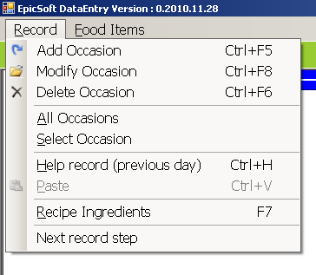
Screen 4.22 Options available under the RECORD menu

- HELP RECORD (PREVIOUS DAY) (Ctrl+H): to copy items/FCO from a food diary of the same subject from a list of previous records press ‘Ctrl+H’, or select from the RECORD menu (Screen 4.22)

If a previous record (food diary) of a subject exists, a window allows selecting one (Screen 4.23).
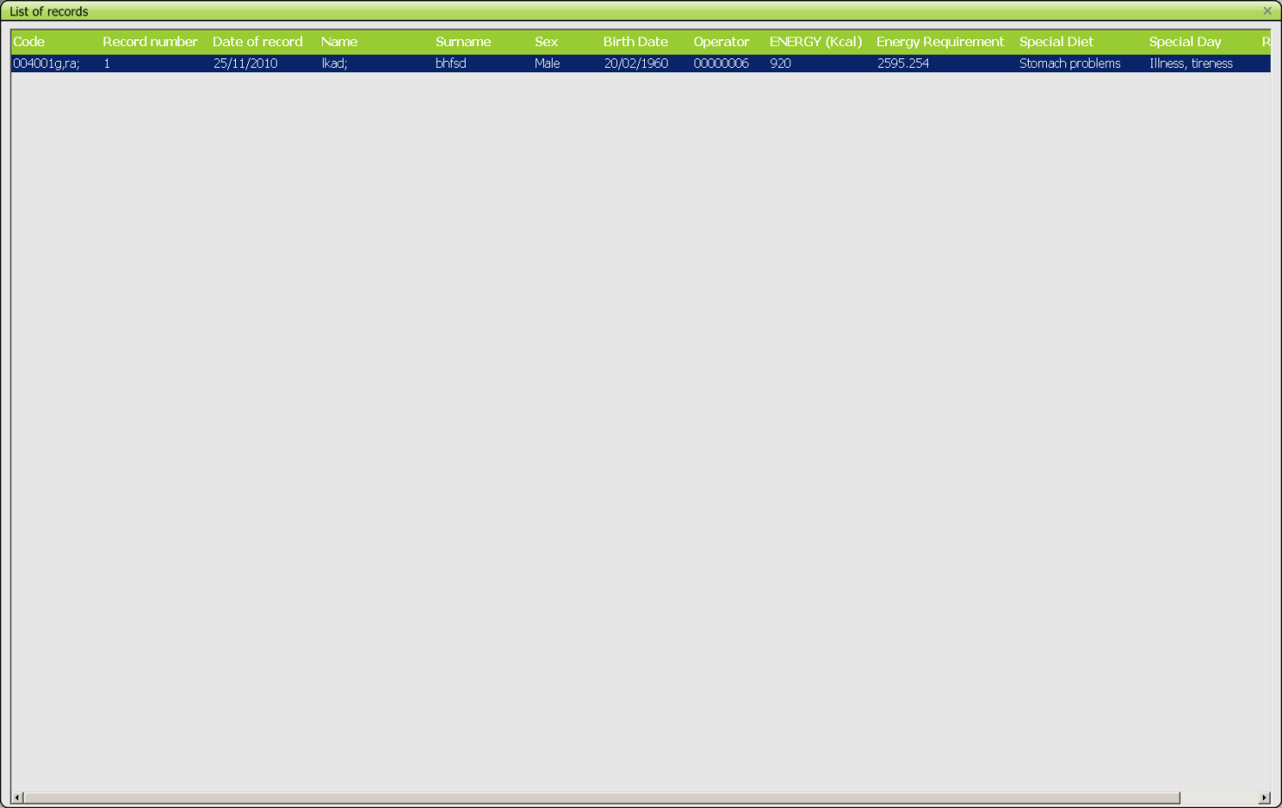
Screen 4.23 Example of a LIST OF RECORDS existing from a subject

In a separate window, the recorded day selected will be displayed (Screen 4.24), and any item can be copied and pasted into the current data entry screen Possible actions are available by ‘menu’ or right/left mouse button (Screen 4.25).
CTRL-C or copy this item to… is possible to memorize an item from this record.
Then it is possible (Ctrl+V) to add a memorized item into the main record (with description/quantification).
An extra “Edit” menu with standard Windows functions is available:
CUT (Ctrl+X) Memorize and cut an item
COPY (Ctrl+C) Copy a memorized item
PASTE (Ctrl+V) Set a memorized item
UNDO (Ctrl+Z) Undo the latest command

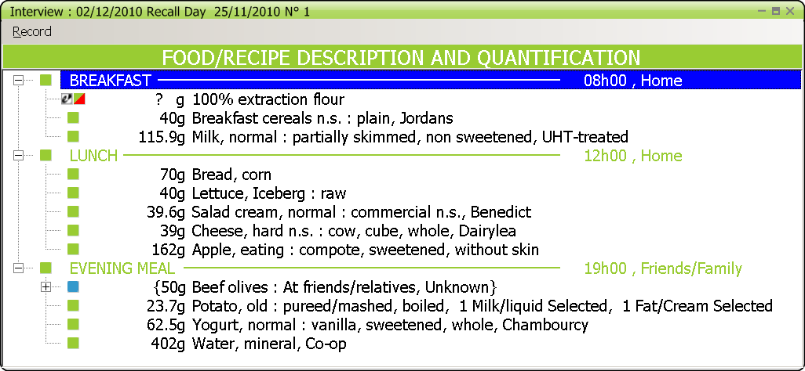
Screen 4.24 Example of an already recorded day from which items can be copied

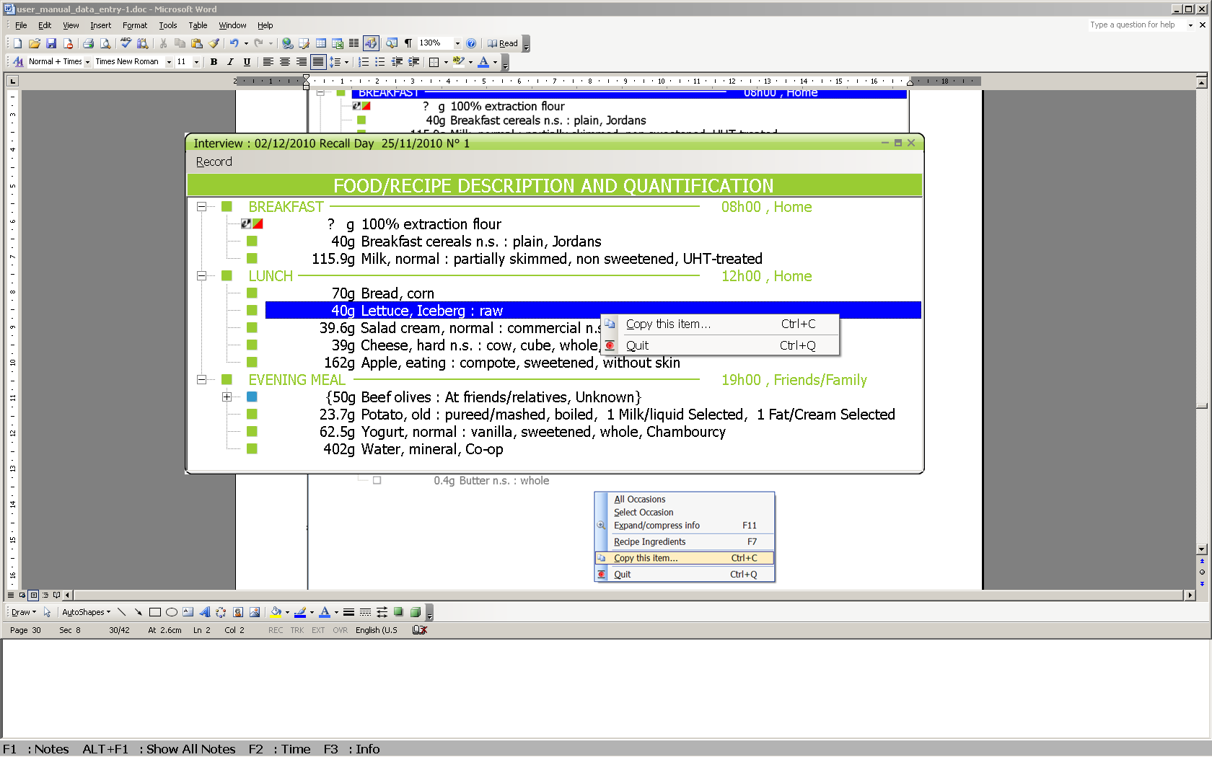
Screen 4.25 Example of copying an item from a previous food diary recorded

Help record is an independent window. ALT-TAB allows switching between main window and help window (small resolution screen).

FOOD ITEMS menu (Screen 4.26)
* ADD ITEM (F4): to add an item; the added food or recipe is inserted at the place where the cursor is focused; after selection of the function, the SEARCH FOR screen opens and the food/recipe can be selected from the list (see description of SEARCH SCREEN)
* DELETE ITEM (F6): to delete an item attached to a FCO
* UNDELETE ITEM (SHIFT + DEL): to list all items that have been deleted during data entry; to undelete an item, set the cursor on this item and select ‘OK’; the cursor will be set on the undeleted item in the FOOD/RECIPE DESCRIPTION AND QUANTIFICATION screen; ‘Cancel’ enables to leave this window without modification

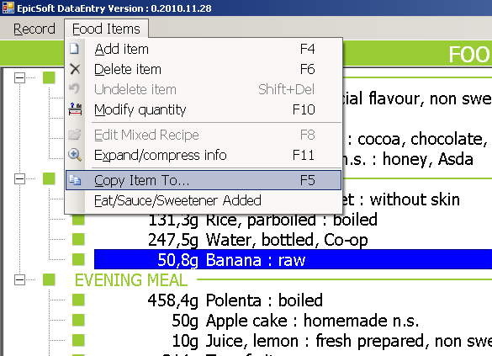
Screen 4.26 Options available under the Food Items menu

* MODIFY QUANTITY (F10): to modify the quantity reported for foods or mixed recipes already described and quantified without having to describe again (for example after having copied an item)
* EDIT MIXED RECIPE (F8): to switch from the FOOD/RECIPE DESCRIPTION AND QUANTIFICATION screen to the STANDARD/INDIVIDUAL RECIPE MANAGER screen to complete information regarding the mixed recipe ingredients; this function is active only if the cursor is focused on a mixed recipe indicated in brackets { }
* EXPAND/COMPRESS INFO (F11): to open (and close) a window with detailed information on the item that the cursor is focused on. Information is given on the method of quantification, the estimated quantity, the finally consumed quantity with the calculation (including raw to cooked, edible part and density factors) and the descriptors selected for the food
* COPY ITEM TO (F5): to copy an already described and quantified food, recipe under another not yet finished item; select by a RETURN or with the mouse, the food or recipe to be copied; a screen containing all the FCO and their corresponding items is displayed; select from this screen by a RETURN the FCO under which the item should be pasted
* FAT/SAUCE/SWEETENER ADDED: to display the screen “fat/sauce/sweetener association table” containing the ingredients attached to a given FCO; the list of ingredients on which standard percentage of fat (sugar, or sweetener) have been applied can be modified

Menu/functions for standard or individual recipes
MANAGER screen(s) (to be used specifically for mixed recipes)

* In the INDIVIDUAL RECIPE screen (this screen is displayed only for individual recipes entered with the option NEW RECIPE):
* NAME field: to enter manually the name of a NEW mixed recipe
* SET GROUP: to complete the GROUP/SUB-GROUP fields; two windows open: on the left side the list of groups, on the right side the list of subgroups and sub-subgroups if available; move from one window to another with TAB and select the (sub-(sub))group

* In the RECIPE INGREDIENT MANAGER screen:
For open recipes, the following functions are available in the INGREDIENTS menu. Some of them are only available when the recipe is known by the subject (individual recipe).
* ADD INGREDIENT (F4): to add an ingredient; the added food is inserted under the ingredient the cursor is focused on; after selection of the function, the SEARCH FOR screen opens and the food can be selected from the list (see description SEARCH screen)
* DELETE INGREDIENT (F6): to delete an ingredient
* UNDELETE ITEM (SHIFT + DEL): to list all the items that have been deleted during the data entry; to undelete an item, set the cursor on this item and select ‘OK’; the cursor will be set on the undeleted item in the FOOD/RECIPE DESCRIPTION AND QUANTIFICATION screen; ‘Cancel’ enables to leave this window without modification
* MODIFY QUANTITY (F10) (only if known recipe): the quantity of ingredients already described and quantified, can be modified with this function without having to re-describe again
* SUBSTITUTE: this option is active on a substitutable ingredient (identified by the prefix SUBST.) on which the cursor is focused, allowing the food to be substituted by another food
* DESCRIBE: to go into the description of a substitutable ingredient
* RECIPE GROUP/SUB-GROUP (only if known recipe): to modify the group/sub-group and the name of the mixed recipe actually displayed
* HELP RECIPE: to display a standard recipe chosen from the recipe list in a separate window
* SAVE RECIPE AND EXIT (F9): to save and exit
* QUIT: to exit without saving

For closed recipes selected from the recipe list, only the four following options are available in the INGREDIENTS menu:
* SUBSTITUTE: this option is active on a substitutable ingredient (identified by the prefix SUBST.) on which the cursor is focused, allowing the food to be substituted by another food
* DESCRIBE: to go into the description of a substitutable ingredient
* EXIT AND SAVE (F9): to save and exit
* QUIT: to exit without saving

  - Quality controls
Different quality controls are made on the data entered at the different steps of the data entry procedure. These are just warnings or helps for the operators. Data entered have to be either confirmed or changed.
- Controls on out-of-range values during the general information step (e.g. date of birth, weight, height);
- Controls on out-of-range values during the quantification of foods and recipes;
- Controls on unknown and overflow quantities which are automatically captured in notes by the system during the data entry (Screen 4.27); before ending the data entry, the UNKNOWN AND OVERFLOW QUANTITY SUMMARY screen listing the FCO with the ‘empty’ item and foods/recipes with missing (or overflow) quantities are displayed; this concerns all the reported foods/recipes for which the UNKNOWN quantification method has been used, those with quantity equal to zero and those exceeding the maxima values; ‘empty’ items should either be quantified or removed before going to the next step.

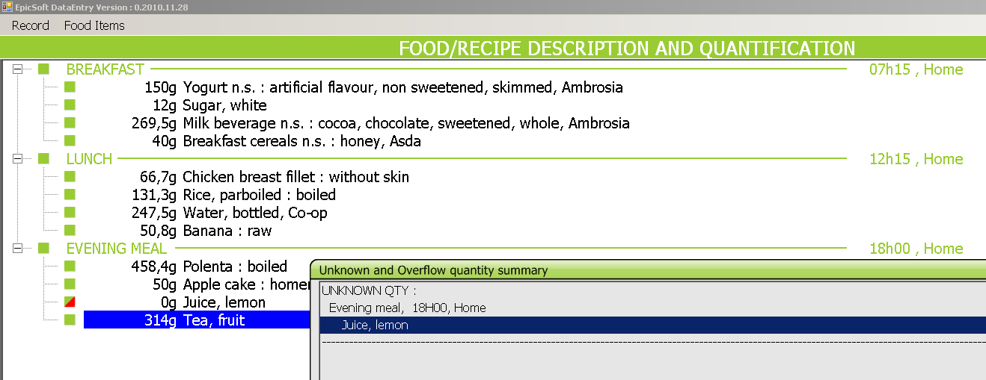
Screen 4.27 Example of UNKNOWN & OVERVLOW QUANTITY summary

- Control at the nutrient level (Screen 4.28); this last quality control step of the data entry compares the estimated energy and macronutrient intakes with age- and sex-specific standard requirements of the subject. The DIETARY RECORD SUMMARY AND FINAL CHECKS screen displays general information on the subject (sex, age, weight,…) and the calculated energy requirement. The estimated intake of energy and macronutrients (in grams and percentage of the energy intake) are reported at the top of the table. If energy or one of the macronutrient values (proteins, fats, carbohydrates, alcohol) estimated from the food diary is out of the expected calculated ranges, a warning TOO LOW or TOO HIGH is displayed. The energy intake and the corresponding "as consumed" weights of foods and ingredients are reported in four main categories (breakfast, lunch, dinner and other, plus total) to check whether an error can explain out of range intake value.

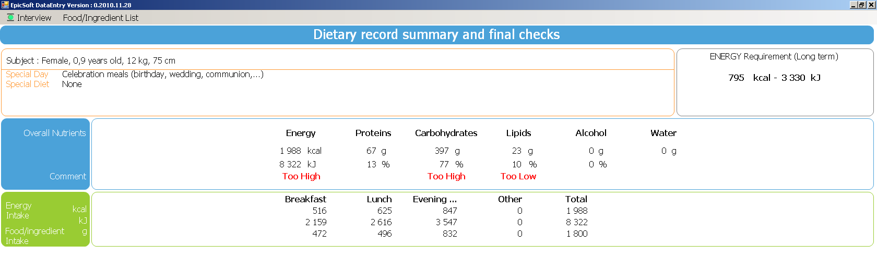
Screen 4.28 Example of a DIETARY RECORD SUMMARY & FINAL CHECKS screen

Summary of menu options related to the final checks
* Description/quantification (F9): to go back to the Description/quantification screen to correct possible errors in the data entered
* Next record step: to proceed to the next data entry step
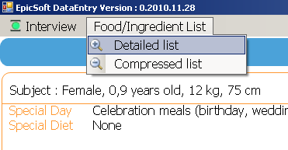
Screen 4.29 Menu option to list quantities of all foods and ingredients entered

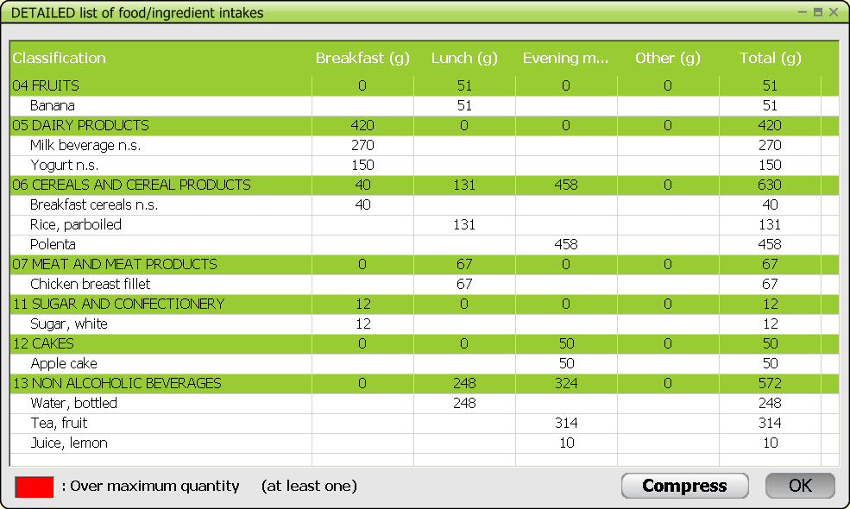
Screen 4.30 Example of detailed list of foods/ingredients entered

* Detailed list (Screen 4.29): to list the quantities of all the foods and ingredients reported in the food diary and their food groups (Screen 4.30).
* Compressed list: to list the quantities of each food group to which all the foods and ingredients reported in the food diary belong.

In both lists, quantities which exceeded the maximum values are written in red.

Note: the detailed and compressed are linked together and one can switch from one to the other by pressing ‘Compress’ or ‘Decompress’. ‘OK’ enables to escape from these screens.

  - Vitamins and other supplements
At the ‘vitamins and other supplements’ step of the data entry, a question whether any dietary supplements have been reported is prompted (Screen 4.31).
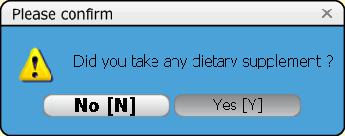
Screen 4.31 Question on dietary supplement consumption

If the answer is ‘YES’, information about vitamins or other supplements (or any medication containing vitamins, minerals...) that have been reported can be entered. Supplement consumption can be linked to a already recorded FCO, to a FCO to be added or an unspecified FCO (Screen 4.32). The latter is automatically displayed in the FCO list.

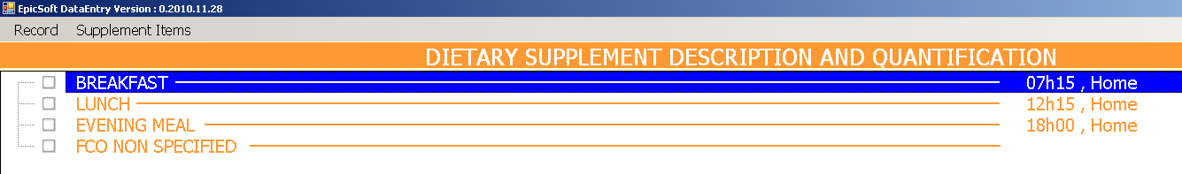
Screen 4.32 Example of DIETARY SUPPLEMENT DESCRIPTION & QUANTIFICATION screen

RECORD menu during the ‘vitamins and other supplements’ step
Availability of functions will depend on the settings chosen.
* Add occasion (F5): to add a FCO; choose from the proposed list and enter the time and place of consumption.
* Delete occasion (F6): to delete the FCO on which the cursor is located, provided this FCO is empty; otherwise a warning ‘Sorry, the FCO item cannot be deleted’ is displayed.
* Modify occasion: to change time and place of consumption.
* Return in description/quantification (F9): to go back to the description/quantification screen.
* End record: to end the data entry session; a question on whether to save the record is asked.

SUPPLEMENT ITEMS menu (Screen 4.33):
* Add item (F4): to open the Search screen to select a supplement
* Delete Item (F6): to delete the indicated supplement
* UNDELETE ITEM (SHIFT + DEL): Function allowing listing all the items that have been deleted during the data entry; to undelete an item, set the cursor on this item and select ‘OK’; the cursor will be set on the undeleted item in the FOOD/RECIPE DESCRIPTION AND QUANTIFICATION screen; ‘Cancel’ enables to leave this window without modification.
* Edit/Modify (F10): to re-describe and re-quantify the current supplement
* Copy Item to …: to copy a supplement into another FCO

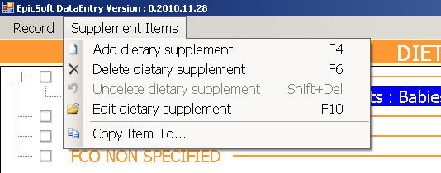
Screen 4.33 SUPPLEMENT ITEMS menu

In the ‘Search for’ screen (Screen 4.34):
VIEW menu:
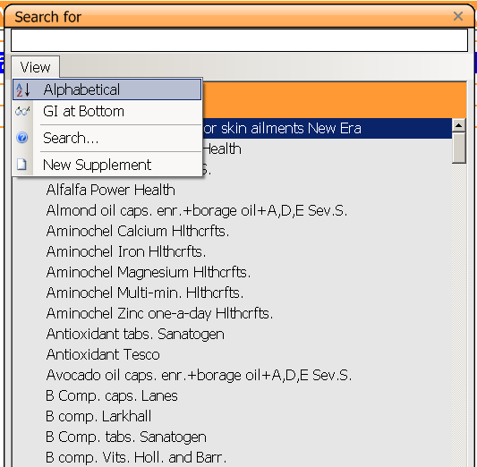
Screen 4.34 Example of SEARCH FOR DIETARY SUPPLEMENT screen

* Alphabetical: displays the supplement list in alphabetical order (default).
* GI at bottom: generic items (ending by n.s.) are reported at the bottom of the displayed list; select again to deactivate.
* Search: to search in the entire dietary supplement list for all the dietary supplements containing a specified ‘search string’, whatever its position in the name; the search is done from the top of the list in alphabetical order; the supplements that contain the ‘search string’ are displayed in a separate window.
* New supplement: to add NEW dietary supplements reported by the subject but not available in the list; classify the new item in its group/subgroup -if relevant- and the facets and quantification methods defined for that group will automatically be shown; if the facet proposed by default is not relevant for describing the new supplement, the option “undefined”, available systematically for each facet, should be selected.

After quantification, the NOTES SCREEN opens automatically in order to enter any additional information that the subject may give about the dietary supplement. All new dietary supplements entered during data entry will be flagged for checking after the data entry whether they need to be added to the dietary supplement database or not.

  - Ending a data entry session of a food diary
Once the option ‘End record’ is chosen in the Record menu, the question “Do you want to SAVE the RECORD?” is prompted on a pop-up window (Screen 4.35).

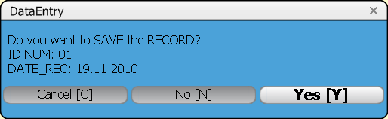
Screen 4.35 Ending data entry of a record

- ‘Cancel’ enables to remain in GLOBODIET
- ‘No’ enables to quit the data entry without saving the record; a warning is displayed where ‘Cancel’ enables to remain in GLOBODIET; when choosing ‘YES’, a message says the record has not been saved; click ‘OK’ and the GLOBODIET start page is displayed with the question ‘Do you want to exit GLOBODIET?’
- ‘Yes’ (SAVE) enables to save the record; messages saying the record is being saved and then that the record has been saved; click ‘OK’ and a question is prompted ‘Do you want to add another record for the same subject?’ (Screen 4.36).
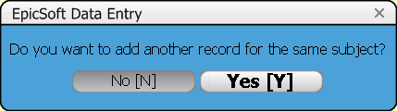
Screen 4.36 Prompting question at the end of a data entry session

- ‘NO’ to the prompting as shown on Screen 4.36, ‘enables’ to exit GLOBODIET; the GLOBODIET start screen is displayed with the question ‘Do you want to exit GLOBODIET?’; with ‘YES’ GLOBODIET is shut down.
- ‘YES’ to the prompting as shown on Screen 4.36, ‘enables’ to continue with entering another food diary for the same subject, General information on the subject is kept in memory and automatically displayed on the ‘subject data’ screen; if needed, information can be modified (e.g. weight, height); consecutively, the ‘RECALLED DAY & WAKE UP TIME’ screen is displayed with ‘SPECIAL DIET’ kept in memory (can also be modified if applicable); the ‘RECALL DAY’ (automatically set at the date of the preceding food diary + 1 day), ‘RECORD NUMBER’, ‘SPECIAL DIET’ and ‘WAKE-UP TIME’ can also be modified manually (Screen 4.37).
- After finishing / confirming the General information on the subject (‘OK’), the OPERATOR continues with selecting the FCO of the respective food diary to be entered.

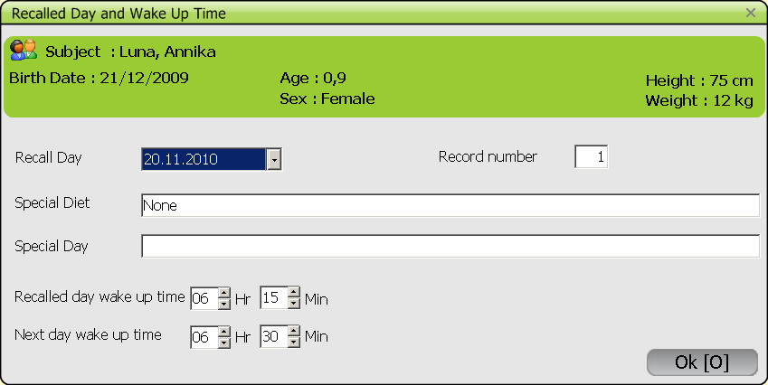
Screen 4.37 Example of RECALLED DAY & WAKE UP TIME screen if data entry is continued for the same subject

- PROCEDURES FOR EDITING A FOOD DIARY
An already performed and saved record (food diary) can be edited. This can be done by selecting the EDIT RECORD option in the ‘Data Entry’ menu of the start screen (Screen 5.1) or by pressing ‘Ctrl+E’.

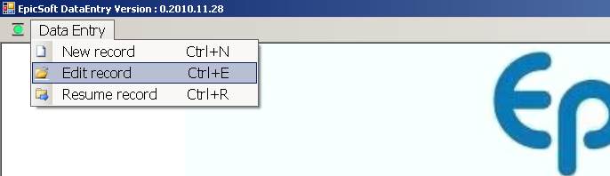
Screen 5.1 Edit record option of the GLOBODIET DATA ENTRY application

After selecting the ‘Edit record’ function, the OPERATOR/CENTER has to be confirmed (‘YES’) or changed accordingly (Screen 5.2).

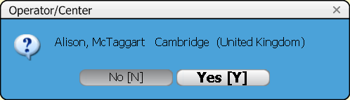
Screen 5.2 Confirmation of OPERATOR/CENTER in the ‘edit record’ mode

The ‘Edit record’ mode is used to read, modify or up-date a record already entered. The notes entered during the interview are an essential tool to upgrade and clean the interviews. A specific icon with a half of red square helps visualize items to be handled in the ‘Edit record’ mode.
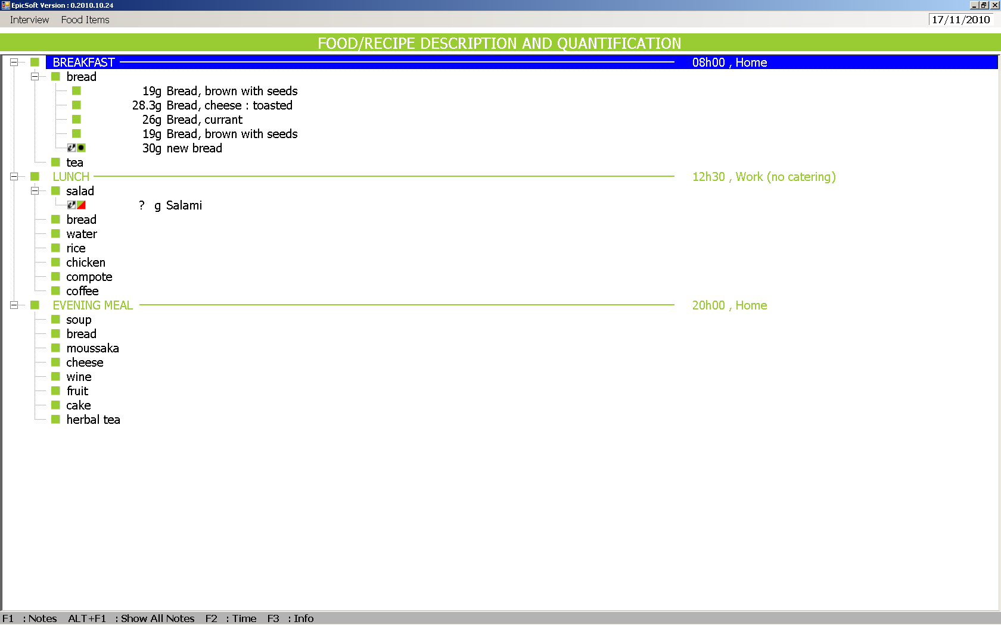

The procedure is the same as for a new record, except for the following functions that are not available (or not active) in the ‘Edit record’ mode:
- In the general information screens, the subject code cannot be changed
- F2 TIME: this function, which gives the duration since the beginning of the data entry, is not active in ‘Edit record’ mode; the duration of the data entry is available for information in the RECORD INFO screen accessible with the key function F3 (INFO) or with the mouse (double click ‘F3’ on the bottom of the screen)

The main difference between the NEW and EDIT mode concerns the handling of recipes. In the ’Edit record’ mode, the RECIPE INGREDIENT MANAGER screen is dedicated to update recipes as reported in the food diary. Therefore, it is possible to add, delete, re-describe and re-quantify each ingredient. The recipe name and classification may be changed by selecting ‘Recipe Groups/Subgroups’ in the Ingredients menu. A Help recipe may be chosen from the recipe list.

Please refer to the GloboDiet user manual for more insightson the EDIT mode.

- APPENDICES
  - Appendix 1: Thesaurus on facets and descriptors
  - Appendix 2: Summary of GLOBODIET functions
  - Appendix 3: How to install and uninstall GLOBODIET

In addition to SI units (cm, kg, L,…) used by default during the data entry, Imperial units (feet, inch, stone, pound, ounce, gallon, quart and pint) can be selected. These British units can be used for both to enter the subject’s weight (feet and inches) and height (stone and pounds) and when the WEIGHT and VOLUME quantification methods, which allow the portion weights or volumes known by the subject to be entered manually, are selected (Screen 4.3). If Imperial units are used during data entry they are automatically converted into grams and both modes of expression are visible on the screen. Even if GLOBODIET is closed, when you open it, the selection is still active.

